Setting Up the IDE+2 (Rev E) for MyDos

1) Attach the PBI adapter and power up the Atari, holding the START button down.

Note: if using an 800XL, there is no power to the PBI. You must add a +5v power lead as shown in the attached picture or attach the IDE power connector to a +5V source on the Atari.

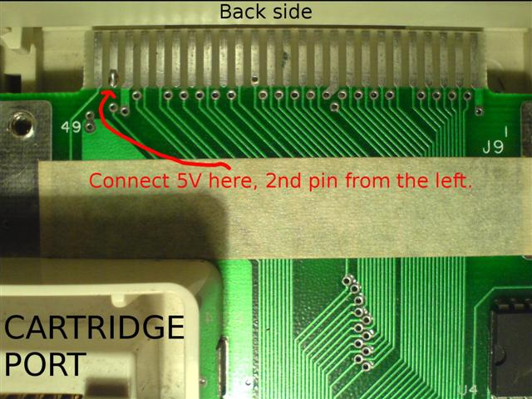

You should enter the Settings Menu. It will look slightly different than this, so press the correct keys until your settings match this one. Press CNTL-X to save your settings. You will likely end up at the self test – no matter. Note – you can set USpeed D1: to on, if you’d rather have it that way. After you get things going, you can set them as you choose.

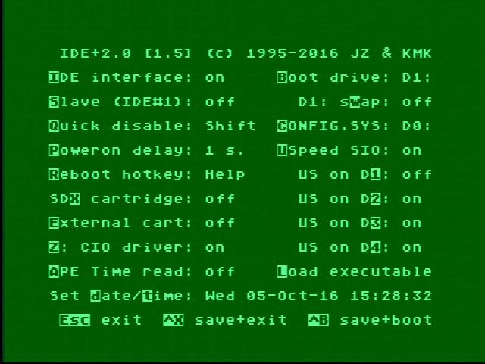

2) Mount the disk/image of the APT Toolkit. as D1: (SIO). Note “Q” – Quick Disable in the menu settings. Holding the Shift key when booting will bypass the IDE drive and boot from D1: on SIO. Note that if you are using a blank card, the system will automatically boot the floppy. Or if you held SHIFT, then you must press RESET to re-establish the link to the IDE+2.

3) Power on the Atari (optionally while holding the Shift key), and you will boot the APT disk. BLOAD the FDISK.COM file. This will allow you to establish your HD partition(s). If it will not recognize your card, it will give an error message to the effect “no APT devices found.”

4) Assuming your card is recognized, press ESC then I for Initialize. From there on you will have to follow the APT menu. You want to set up D1: as you want it, including the MBR, 256 BPS, Active + MBR + Master Boot Record. Name the partition if you wish. (IMO, Konrad’s old FDISK2 software was quite a bit easier to use, but his new Rev E bios no longer recognizes the old FDISK2, so you must use the APT FDISK.)

The APT partition screen should look much like this. Your Size (#sectors) may be different.

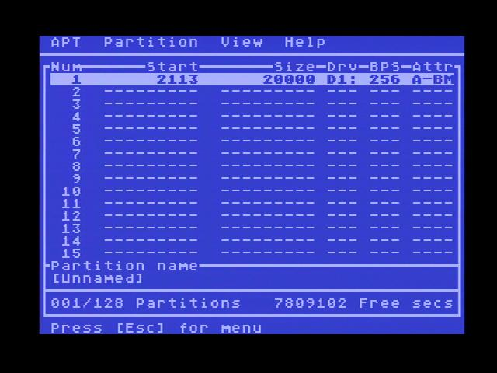

5) Save the partition data with CNTL-W, then exit. You will likely have to reboot to the floppy D1: MyDos menu. Press RESET. That will re-establish the IDE as D1:

6) Use the MyDos O configuration command to set up your D1 in MyDos to match the APT partition.
Remember when formatting the MyDos IDE Plus hard drive, you must use 1/N in the format description of “disk to format”. This helps prevent an accidental format of the hard drive.

7) Write the Dos files to the HD and you should have a bootable drive!

Appendix: Rev E Controls and Switches:

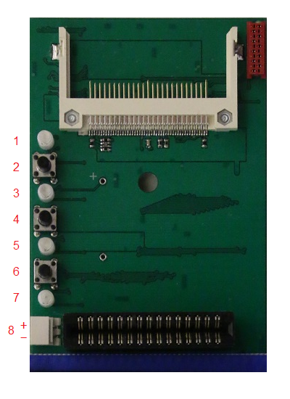
1 - CF activity LED (blue)
2 - SWAP switch
3 - SWAP LED (orange)
4 - SDX on/off switch
5 - SDX on/off LED (green)
6 - Write protect switch
7 - Write protect LED (red)
8 - Power supply connector

